**Experiment 8**

**Shashwat Tripathi**

**D15A Batch C  
RollNo: 64**

**AIM : Recommendation system using Machine Learning**

**THEORY :**

**What is Recommendation System?**

A Recommendation System is a type of information filtering system that predicts and suggests items or products to users based on their preferences, interests, and past behaviors. These systems are widely used in various online platforms such as e-commerce websites, streaming services, social media platforms, and more.

The primary goal of a Recommendation System is to enhance user experience by providing personalized and relevant recommendations, thereby facilitating decision-making and increasing user engagement and satisfaction. There are several approaches to building Recommendation Systems, including collaborative filtering, content-based filtering, and hybrid methods that combine both approaches. These systems leverage machine learning algorithms and techniques to analyze large datasets of user interactions, item attributes, and other relevant features to generate accurate and effective recommendations. Evaluation of Recommendation Systems typically involves metrics such as precision, recall, and accuracy to assess their performance and effectiveness in meeting user needs and preferences.

**Types of Recommendation Systems**

Recommendation systems can be broadly classified into three main types based on their underlying techniques and approaches:

1. Collaborative Filtering:

Collaborative filtering methods recommend items to users based on the preferences and behaviors of similar users. These methods do not require explicit knowledge about the items or users but rely on the historical interactions or ratings provided by users. Collaborative filtering can be further divided into two sub-types:

- User-based Collaborative Filtering: This approach recommends items to a target user based on the preferences of users who are similar to that target user. It identifies users with similar patterns of item interactions and recommends items that these similar users have liked or interacted with in the past.

- Item-based Collaborative Filtering: In this approach, items are recommended to a user based on the similarity between items. It analyzes the interactions between items and recommends items that are similar to the ones that the user has interacted with previously.

2. Content-based Filtering:

Content-based filtering methods recommend items to users based on the characteristics or attributes of the items and the user's preferences. These methods analyze the features or attributes of items and create a profile representing the user's preferences. Items with similar features to those liked by the user are recommended. Content-based filtering is particularly effective when there is sufficient information about the items available, such as textual descriptions, tags, or metadata.

3. Hybrid Recommendation Systems:

Hybrid recommendation systems combine multiple recommendation techniques to overcome the limitations of individual approaches and provide more accurate and diverse recommendations. These systems leverage the strengths of collaborative filtering and content-based filtering methods to improve recommendation quality. Hybrid systems can be implemented in various ways, such as by combining the outputs of different recommendation algorithms, incorporating user feedback to adjust recommendations, or using a hybrid model that integrates both collaborative and content-based approaches in a single framework.

Each type of recommendation system has its advantages and limitations, and the choice of the most suitable approach depends on factors such as the nature of the available data, the specific application domain, and the desired level of personalization and accuracy. Experimentation and evaluation are crucial in determining the effectiveness of different recommendation techniques and optimizing the performance of recommendation systems for specific use cases.

**OUTPUT :**

**Importing Libraries**

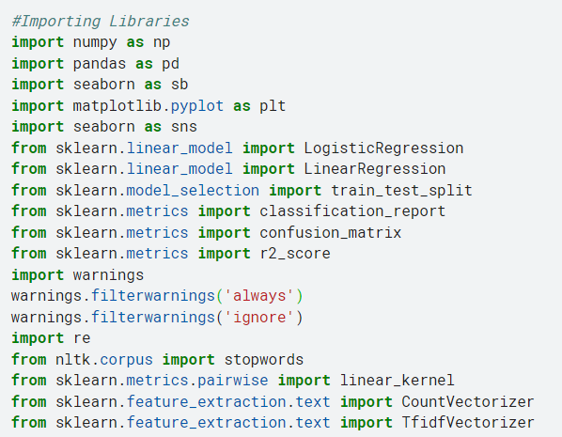

**Loading the Dataset**

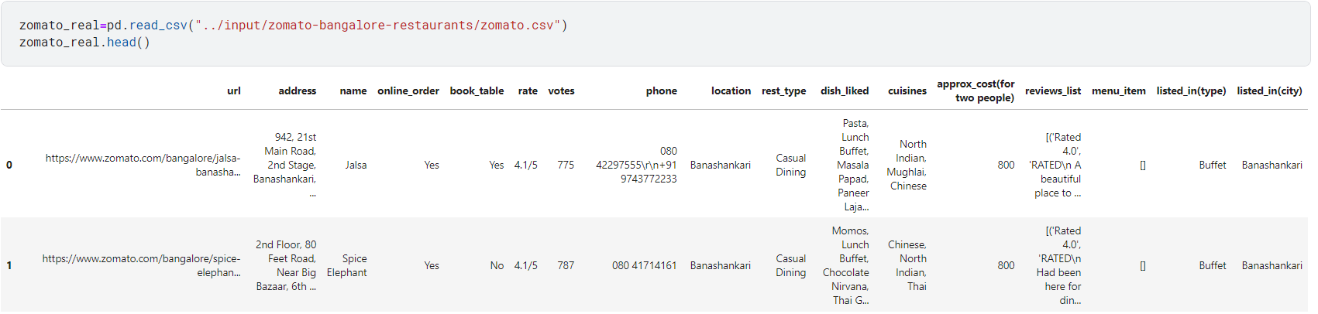

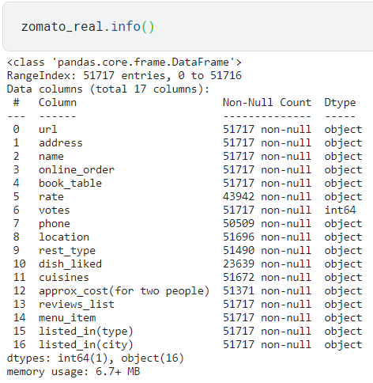

**Cleaning the dataset**

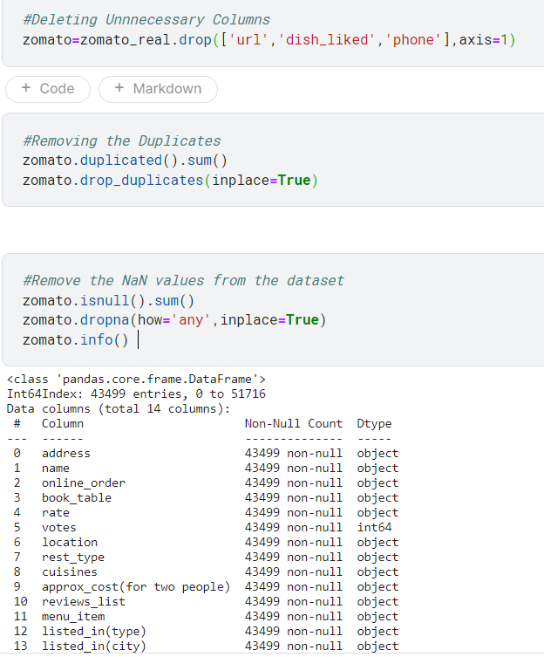

**Reading the rating of restaurants and removing the /5.0 from each cell**

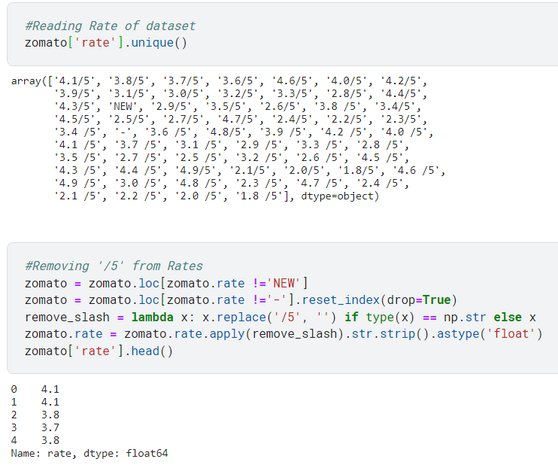

**Counting the unique places inside Bangalore**

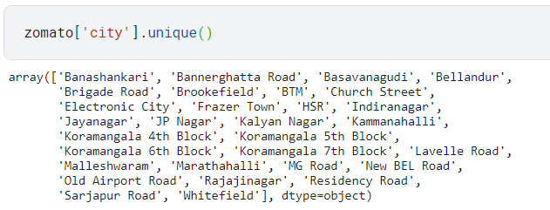

**Calculating the mean rating**

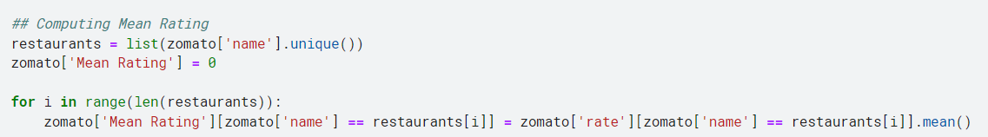

**Checking the review list and restaurant names**

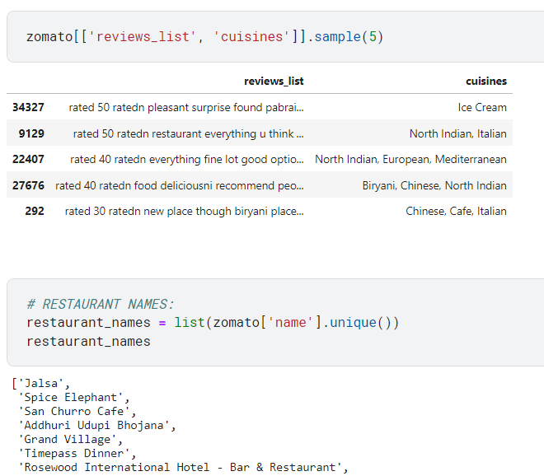

**Term Frequency-Inverse Document Frequency**

Term Frequency-Inverse Document Frequency (TF-IDF) vectors for each document. This will give you a matrix where each column represents a word in the overview vocabulary (all the words that appear in at least one document) and each column represents a restaurant, as before.

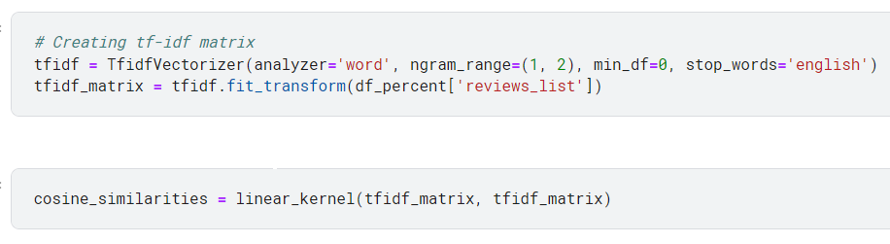

**The main recommendation function**

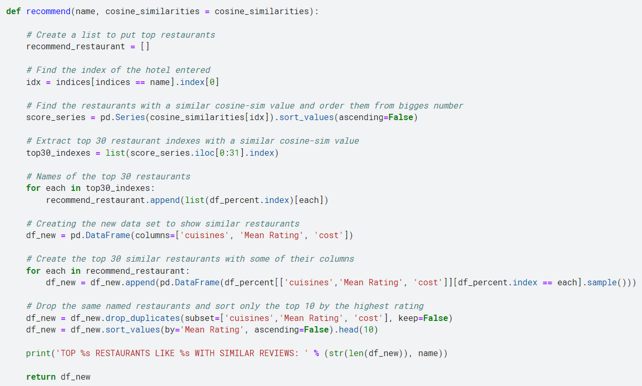

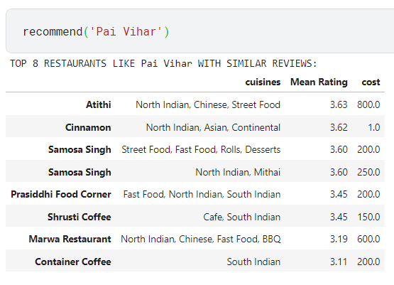

**CONCLUSION : Thus, we have created a recommendation system based on a prompt of restaurant that recommends us similar list of restaurants which are nearby.**